### Design three segments of LAN using packet tracer with the following:

### 3 switches connected to each other

### 5 computers are attached to each switch

### Assign IP address starting from the series 192.168.1.1 to 192.168.1.15

### Verify the three segments by pinging from the computer in one segment to the computer in another segment.

### Design five segments of LAN using packet tracer with the following:

### 5 switches connected to each other

### 5 computers are attached to each switch

### Assign IP address starting from the series 192.168.1.1 to 192.168.1.5 to segment 1

### Assign IP address starting from the series 192.132.1.6 to 192.168.1.10 to segment 2

### Assign IP address starting from the series 192.168.1.7 to 192.168.1.11 to segment 3

### Assign IP address starting from the series 192.140.1.8 to 192.140.1.12 to segment 4

### Assign IP address starting from the series 192.168.1.13 to 192.168.1.17 to segment 5

**Section A : Design an IP Addressing Scheme**

You are given the network address of 192.168.150.10 and requested to subnet and provide the IP addressing for the network shown in the topology shown below. Each LAN in the network requires enough space for minimum 27 addresses for end devices.

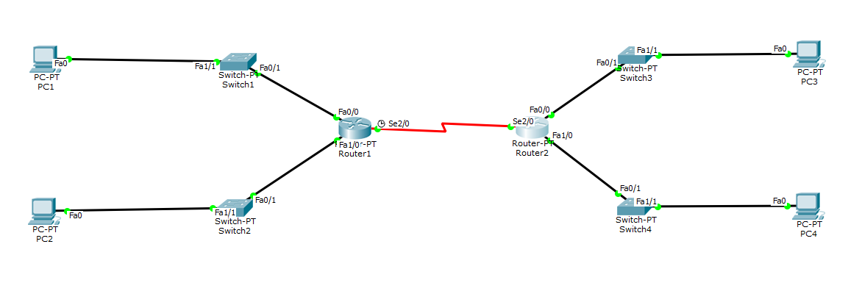

1. What is the default subnet mask for the given the network address?
2. Based on the topology, how many subnets are needed?
3. How many bits must be borrowed to support the number of subnets in the topology?

1. What are the total subnets for borrowed bits?
2. How many usable hosts does this create per subnet?
3. What is the new subnet mask?

1. What is the network address for the IP address?
2. Fill in the Table below, listing the decimal value of all available subnets, the first and last usable host address, and the broadcast address. Repeat until all addresses are listed.

**NOTE: YOU MAY NOT NEED TO USE ALL ROWS**

|  |  |  |  |
| --- | --- | --- | --- |
| **Subnet number** | **Network ID** | **Useable Hosts** | **Broadcasting Address** |
| **0** |  |  |  |
| **1** |  |  |  |
| **2** |  |  |  |
| **3** |  |  |  |
| **4** |  |  |  |
| **5** |  |  |  |
| **6** |  |  |  |
| **7** |  |  |  |
| **8** |  |  |  |
| **9** |  |  |  |

**Section B: Packet Tracer Configuration**

**Instruction:**

1. Please use “Generic” type for router (Router-PT) and switch (Switch-PT).
2. Verify the connection:

* PC1 must can ping PC3
* PC2 must can ping PC4
* PC3 must can ping PC2
* PC4 must can ping PC1

**……………………………………………………………………………………………………**

1. Follow the figure from **Section A**, create the topology diagram and connect all devices by using Packet Tracer (choose correct devices and cabling) accordingly.
2. Configure the Routers’ interfaces, Ethernet interfaces of all PCs with IP addresses, and the default gateway with IP addresses from the table from **Section A**. Use the table below to help you assigning IP addresses properly

| **Device** | **Interface** | **Network Address** | **IP Address** | **Default Gateway** |
| --- | --- | --- | --- | --- |
| **R1** | **Fa0/0** |  |  | N/A |
| **Fa1/0** |  |  | N/A |
| **Se2/0** |  |  | N/A |
| **R2** | **Fa0/0** |  |  | N/A |
| **Fa1/0** |  |  | N/A |
| **Se2/0** |  |  | N/A |
| **PC1** | **NIC** |  |  |  |
| **PC2** | **NIC** |  |  |  |
| **PC3** | **NIC** |  |  |  |
| **PC4** | **NIC** |  |  |  |

1. Verify the network by using PING command and try to ping between all PCs.